JEM1 Specifications

Post Review Version 0.2 17.7.03

Due to the tight schedule it was decided to simplify the non-real time circuitry on JEM1 and thus reduce design effort, PCB complexity, and probably PCB cost. Basically all board control and timing functionality, previously allocated to two FPGAs (XC2V1000 – BG575) will be moved into a single large FPGA (XC2V2000 – BF957). Signal routing will be simplified since signals will run between the input daughter modules and two rather than three large devices only. The recent idea of placing control functionality on a daughter module was given up due to the low per-pin cost of the 1.27mm pitch flip-chip device. It is identical to the device originally envisaged for the main processor.

The abundant pin resources on the device allow for detaching the energy sum algorithm from jet code and relocating it to the control device. This leads to a more balanced allocation of logic resources: The combined jet/energy algorithm might have filled the XC2V2000 to a large percentage, in particular if a slightly more complicated forward jet algorithm were chosen. The control chip is severely pin bound and hardly any logic resources are used at all. The energy sum algorithm will fit nicely and due to the low use of logic resources the routing delays will be reduced. The scheme had originally been envisaged for JEM0 but had been given up on due to the far higher cost per pin on Virtex-E. Since JEM1 is using Virtex2 throughout, the modification to the architecture has a low impact on silicon cost only since now a single device at $513.70 replaces two devices at $223.30 each.

The two processors on the JEM will be named Jet processor and Sum processor, with the Sum processor including board control and timing control. The ROC functionality is absorbed into the timing control circuitry, the actual data path to DAQ and Level-2 is handled in two separate instances of a G-Link controller. There are plenty of spare pins available on each of the processors. They will be wired such that future upgrades of the algorithms will be possible. The impact on the firmware development is limited. The jet code is a well isolated algorithm already now. The input processor code, the energy sum code and the control code are currently undergoing a cleanup and the functional blocks of the new code will be suitable for deployment in either the old or the new JEM. Energy sum latency is expected to go down due to 40Mbit/s non-multiplexed data paths.

The JEM1 specifications have been updated to reflect the changes:

The new JEM will be built mainly to the specifications laid out for the JEM0 prototype. There are major differences in the detailed implementation. Also, some specifications change. This document tries to summarise design changes. Full updated specifications will be made available at a later stage.

Architectural issues
While JEP1 will run the same algorithms as JEP0, they are partitioned into physical components in a different way. The 11 phi bins, which are processed in 11 individual input FPGAs on JEM0, are now allocated to four input processors processing 3(2) phi bins each. The logic and I/O capacity of the physical devices is chosen appropriately. Each input processor is mounted on a daughter module along with 4 de-serialiser chips. All backplane signals are 60Ω back-terminated, as on JEM0. FPGA-internal DCI termination replaces the termination resistors used in the previous design. The 88 serial input channels are now de-serialised in 6-channel link chips. The reference clock is now supplied to the de-serialisers via the input processors.

The control circuitry was re-partitioned so as to move energy summation, board control, and TTC-interface into the same physical device. The device type has been chosen accordingly. The device is named Sum processor now. The former main processor is renamed Jet processor.

Board-level VME is routed now from the Sum FPGA to all individual processors on point-to-point links. They operate as described for the JEM0 main processor. The ring bus has disappeared. The VME bus width has been slightly increased. On the backplane, however, the control bus complies with VME⁻⁻ specifications.

All FPGAs are configured from Xilinx SystemACE at power-up via JTAG automatically. It will be possible to automatically select one specific configuration out of 8 based on the geographic address of the module. Configuration updates will be possible by exchanging the flash memory (slot in the front panel) or later via in-situ update, once driver software becomes available. During the debug phase it will be possible to configure the FPGA by direct VME access through a CPLD or small fixed-configuration FPGA.

Other changes
The two main board resident FPGAs are 1.27mm BGA Virtex-2 as opposed to the 1mm pitch Virtex-E and Spartan-2 devices used previously.

CAN access will be provided in a way compatible to the CP and the PPr. The design will be an exact copy of the CAN interface found on the CP.

The TTCrx functionality will be provided by a TTCdec module mounted on the JEM. Unlike JEM0, JEM1 will allow for full access to all TTCrx signals. TTC control and command decoding will be handled in the Sum processor, based on the JEM0 ROC/control scheme. The clock mirror was moved out of the FPGA and is built from buffer chips in the PLL loop.

Due to the larger number of JTAG devices on JEM1, the scan chain will be split and the de-serialisers, FPGAs and CPLDs are connected to a front panel header on separate pins.

The VME memory map will be similar to the one of the JEM, so as to simplify the transition in the slice test. At a later stage a re-map corresponding to the new architecture might be considered.

Bug fixes
Some minor bugs need to be fixed on JEM1:
The cable GND will be run via jumpers onto common GND. This was correctly specified in the JEM0 documents but incorrectly implemented on the modules.

Thermal issues
On JEM0 power consumption has been low. There was no need for heat sinks on any FPGA. This is due to the fact that the devices are run at 80 MHz maximum internal clock frequency only. On JEM1 specific consumption is expected to be lower due to the faster process. There should be no problems to move the algorithms from 3 input FPGAs into a single flip-chip package, even if located on daughter modules. Thermal properties of flip-chip devices are expected to be superior to the previously used wire bonds. Passive components on the daughter modules will be located such that the air flow will not be obstructed.

The Jet and Sum processors will be mounted on the JEM1 main board and will be cooled by full air flow. Mounting holes for CP-style heat sinks will be considered.

PCB issues
Unlike the FPGAs used on JEM0, the de-serialisers as well as the Virtex-2 processor chips are BGAs that require large numbers of signal tracks to be routed near the centre of the ball array. This leads to an extremely high density of vias. This is clearly shown in the Xilinx reference design (see figure). All pins except the outer two rows are connected to a via. On layer1 two tracks are routed between 1mm-spaced vias.

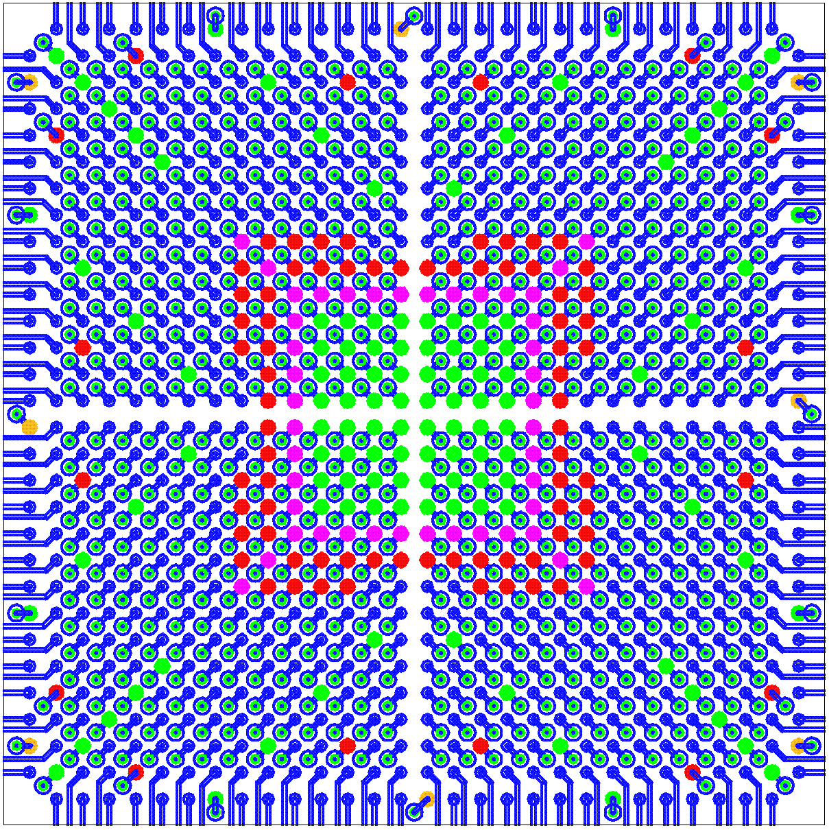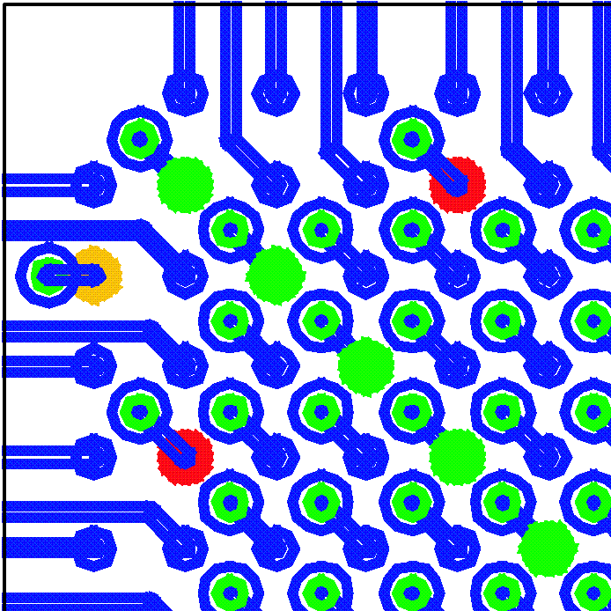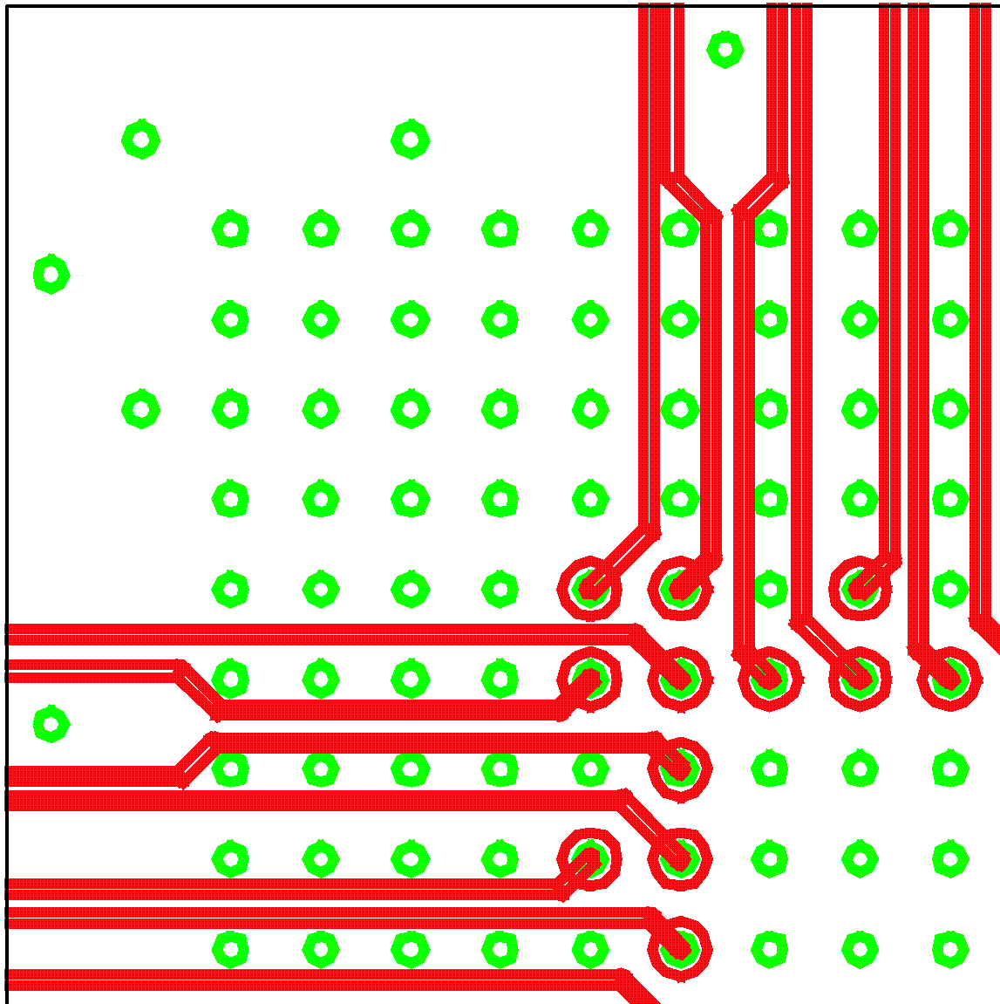
top top layer1

On V_{cc} and GND planes the anti-pads need to be below 850µm of diameter, so as to leave a minimum of 150µm of metal between two 1mm spaced vias. This is certainly the minimum required for high quality power/ground distribution.

The required precision is industry standard technology for small and thin PCBs. On large PCBs, however, this precision cannot be guaranteed. On 9U*40cm PCBs Andus accept anti-pads of 900µm for 2mm thick PCBs of that size. For 1.6mm boards 850µm anti-pads are acceptable. This is just about enough to route a single track between two vias. The Xilinx reference layout, however, cannot be used in this case and 6 layers are required rather than 4 for routing the signal tracks away from the chip. While the input FPGAs could, at higher cost, be chosen to be 1.27mm-BGAs, the de-serialisers are available in fine pitch package only.

Daughter modules
The track and via density required for fine pitch BGAs is more easily handled on small daughter boards. One input processor along with four de-serialiser chips per daughter module covers three bins in φ (24 channels). The daughter modules will carry hardware revision (4 bit, hard-wired) and serial number (8bit) encoded on solder jumpers. The hardware revision will be readable via the Sum FPGA, to allow for selection of a suitable configuration file.

Mother board
With the input stage located on daughter modules, there are no 1mm-BGAs are required on the mother board. 1.27mm ball grid packages are available to suit Jet and Sum processor (BF957). 1.27mm pitch devices can be routed according to the Xilinx reference designs, only a few modifications are required to avoid 3 signal lines being routed through two adjacent vias.

A coarse floor plan shows the input daughter modules as well as the FPGAs mounted on the mother board (drawing not updated to show the Sum FPGA):
http://www.uni-mainz.de/~uschaefe/browsable/JEMdocs/JEM1/JEM_Daughter1.pdf

Suitable daughter connectors are available from Samtec. There exists a variety with well-defined differential impedances (for serial link tracks), too. Data sheets (header/socket, single ended and differential) are available at:
http://www.samtec.com/ftppub/pdf/QTH.PDF
http://www.samtec.com/ftppub/pdf/QSH.PDF
http://www.samtec.com/ftppub/pdf/QTH_DP.PDF
http://www.samtec.com/ftppub/pdf/QSH_DP.PDF

V
M
E
88 pair
each 165 pins FIO
60 bit 80Mb/s
TTCdec
CAN
System
ACE
3 x 3 x 12 bit 40 Mb/s
DES
DES
DES
DES
Input

2 B
1 A
0 V
60
60
40
Input

5 E
4 D
3 C
Input

8 H
7 G
6 F
Input

--
10 X
9 W
DAQ/Timing/VME
To JMM
G
G

Jet
R
S
T
U

Sum
To SMM
DAQ
ROI

Signal levels and signal integrity
On JEM1 Virtex-II devices are used throughout, so as to benefit from 1.5V I/O. All single-ended signal lines on the JEM are routed at 60 Ohms impedance and the DCI facility is used to source-terminate the signals. DCI termination is available at signal levels of 1.5, 1.8, 2.5, and 3.3 V. For reason of system noise the following choices have been made (signal levels/V_{CCO}):

Input processors : 1.5V only except configuration and static lines
Jet processor : mainly 1.5V, JMM lines at 2.5V, few 3.3V low drive strength lines
Sum processor: links to Input and Jet : 1.5Vonly, except configuration lines
SMM 2.5V
VME, CAN, TTC, G-link, 3.3V low drive strength
B/scan all 3.3V (V_{CCAUX})

Supply voltages (core) :
G-link 5V
PECL driver 3.3V
VME buffer 3.3V
DTACK buffer 3.3V
FPGAs 1.5V
De-serialiser 3.3V Digital/Analog
CAN 5V
TTCrx 3.3V

Regulators are switch type, except 2.5V, which might be linear due to low consumption

Placement and routing
All active components are on top, tantalums as well. The solder side carries ceramic capacitors only. Daughter modules may carry components on either side. All signal tracks are 60 Ohms. All FPGA output lines are source terminated 60 Ohms. High voltage-level signals are routed on short tracks only, far away from low level signals and on separate signal layers.

List of active devices:
De-serialiser: 6-channel type SCAN 921260, 1mm BGA
Input : XC2V1500 – 4 FF896
Jet, Sum : XC2V2000 – 4 BF957

Summary of modifications with respect to JEM0
- Replace de-serialisers by compatible 6-channel devices with B/Scan facility
- Replace 11 input FPGAs by 4 Virtex-II chips on individual daughter modules
- Make input FPGA control path compatible to the one previously used on main processor
- Replace main processor by larger Virtex II : Jet processor
- Use 1.5V signals where possible (previously 2.5V)
- Use internal source termination ( DCI ) on all signals
- Provide full access to all TTCdec daughter signals
- Move energy summation, TTC control, clock mirror and ROC to one common device
- Configure all FPGAs via SystemACE
- Make CAN H/W compatible to CP

Change log:
15.7.03
- Add description of common Sum/control FPGA
- new FPGA names: Sum and Jet FPGA
- refer to TTCdec module for timing control
- new clock distribution scheme due to TTCdec PLL
- update block diagram
- rename top phi bin to X (according to new naming convention S. Hillier)

Series resistors required for 5V tolerance
G-link inputs are true TTL levels (V_{IH}=2V). Therefore the G-links might be driven off a V_{CCO}=2.5V bank to allow for efficient use of the pins available on the Sum FPGA

