JEM1 Specifications

The new JEM will be built mainly to the specifications laid out for the JEM0 prototype. There are major differences in the detailed implementation. Also, some specifications change. This document tries to summarise design changes. Full updated specifications will be made available at a later stage.

Due to the high via density the PCB is expected to be complex and expensive. Currently the option of a mother/daughter construct is being explored.

Architectural issues
While JEP1 will run the same algorithms as JEP0, they are partitioned into physical components in a different way. The 11 phi bins, which are processed in 11 individual input FPGAs on JEM0, are now allocated to four input processors processing 3(2) phi bins each. The logic and I/O capacity of the physical devices is chosen appropriately. All backplane signals are 60Ω back-terminated, as on JEM0. FPGA-internal DCI termination replaces the termination resistors used in the previous design. The 88 serial input channels are now de-serialised in 15 6-channel link chips. Reference clock is now supplied to the de-serialisers via the input processors.

The control circuitry was re-partitioned so as to move ROC and TTC-interface into the same physical device. The device type has been chosen accordingly.

Board-level VME is routed now from the control FPGA to all individual processors on point-to-point links. They operate as described for the JEM0 main processor. The ring bus has disappeared. The VME bus width has been slightly increased. On the backplane, however, the control bus complies with VME⁻⁻ specifications.

The control FPGA contains no physics-related algorithms and will always run on a fixed configuration. It replaces the CPLDs used for VME and configuration storage sequencing on JEM0. The control FPGA is configured from a XC18V00 memory at power-up. It will be ISP’ed via JTAG. A socket may be provided for a small CPLD to speed up configuration changes during the debug phase. There will be no CPLDs on the production modules.

Other changes
The main processor is turned into a Virtex II so as to benefit from the hardware multipliers. No other changes are envisaged for the main processor.

CAN access will be provided in a way compatible to the CP and the PPr. The design will be an exact copy of the CAN interface found on the CP.

The configuration memories will be chosen compatible to the one on the CP. They will be socketed (?). Since the configuration memory is connected to the control FPGA only, a small number of bused devices will be employed to store multiple configurations of any of the 3 processor FPGA types. The sequencer algorithm is located in the fixed configuration of the control FPGA and configurations cannot therefore be accidentally routed to the wrong FPGA. The total capacity is large enough to hold a minimum of 6 different configurations (2 configurations each for 3 FPGAs) of XC2V2000 size (8Mbit). The control FPGA contains large enough an amount of block memory to buffer large blocks of data so as to allow for fast re-programming of the flash memory via the VME bus.

A decision on the TTCrx chip (board mount vs. daughter module, flavour of daughter module) will be taken based on the recommendations of the reviewers and depends on the overall module implementation (daughter vs. single board). Unlike JEM0, JEM1 will allow for full access to all TTCrx signals. TTC control, clock fan-out and command decoding will be handled in the ROC, based on the JEM0 scheme.

Due to the larger number of JTAG devices on JEM1, the scan chain will be split and the de-serialisers are connected to (a) separate header(s).

The VME memory map will be compatible to the one of the JEM, so as to simplify the transition in the slice test. At a later stage a re-map corresponding to the new architecture might be considered.

Bug fixes
Some minor bugs need to be fixed on JEM1:
The cable GND will be run via jumpers onto common GND. This was correctly specified in the JEM0 documents but incorrectly implemented on the modules.

Thermal issues
On JEM0 power consumption has been low. There was no need for heat sinks on any FPGA. This is due to the fact that the devices are run at 80 MHz maximum internal clock frequency only. On JEM1 specific consumption is expected to be lower due to the faster process. There should be no problems to move the algorithms from 3 input FPGAs into a single flip-chip package, even if located on daughter modules. Thermal properties of flip-chip devices are expected to be better than the previously used wire bonds. Passive components on the daughter modules will be located such that the air flow will not be obstructed.

The main processor will in either case be mounted on the JEM1 main board and will be cooled by full air flow. Mounting holes for a CP-style heat sinks will be considered.

PCB issues
Unlike the FPGAs used on JEM0, the de-serialisers as well as the Virtex-2 processor chips are BGAs that require large numbers of signal tracks to be routed to or near the centre of the ball array. This leads to an extremely high density of vias. This is clearly shown in the Xilinx reference design (see figure). All pins except the outer two rows are connected to a via. On layer1 two tracks are routed between 1mm-spaced vias.

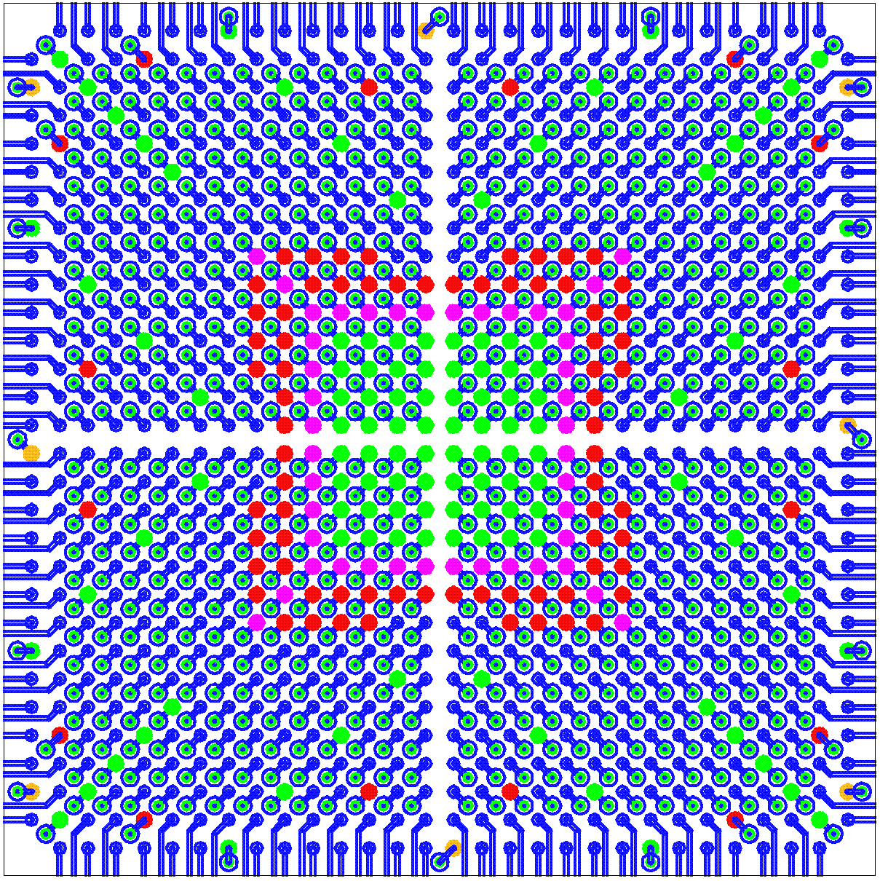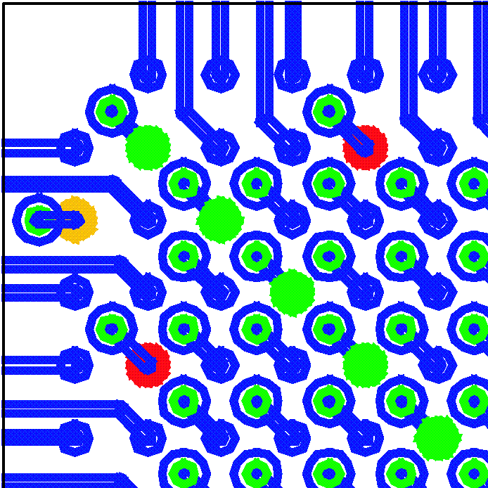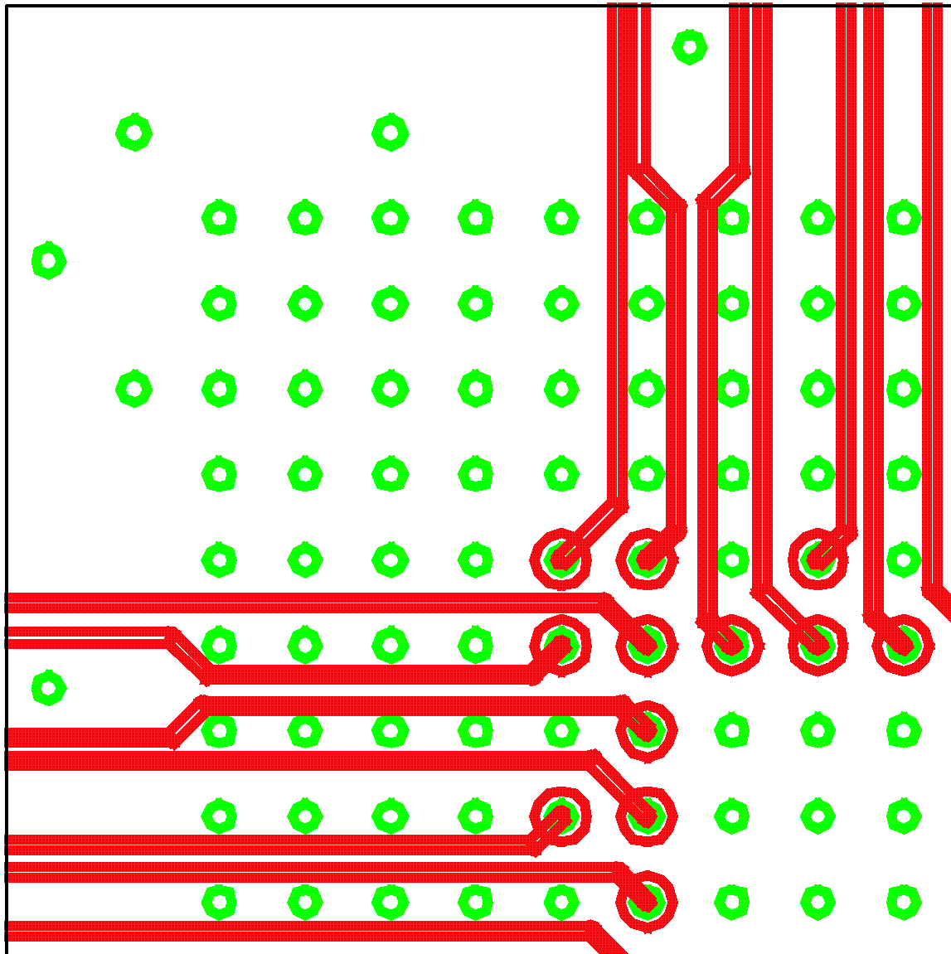
top top layer1

On V_{cc} and GND planes the anti-pads need to be below 850µm of diameter, so as to leave a minimum of 150µm of metal between two 1mm spaced vias. This is certainly the minimum required for high quality power/ground distribution.

The required precision is industry standard technology for small and thin PCBs. On large PCBs, however, this precision cannot be guaranteed. On 9U*40cm PCBs Andus accept anti-pads of 900µm for 2mm thick PCBs of that size. For 1.6mm boards 850µm anti-pads are acceptable. This is just about enough to route a single track between two vias. The Xilinx reference layout, however, cannot be used in this case and 6 layers are required rather than 4 for routing the signal tracks away from the chip. While the input FPGAs could, at higher cost, be chosen to be 1.27mm-BGAs, the de-serialisers are available in fine pitch package only.

Daughter modules
The track and via density required for fine pitch BGAs is easily be handled on small daughter boards. One input processor along with four de-serialiser chips per daughter module covers three bins in φ (24 channels). The daughter modules will carry hardware revision (4 bit, hard-wired) and serial number (8bit) encoded on solder jumpers. The hardware revision will be readable by the control FPGA on the mother board, to allow for selection of a suitable configuration file.

Mother board
With the input stage located on daughter modules, there are no f-BGAs are required on the mother board. 1.27mm ball grid packages are available to suit main processor (BF957) ROC, and control FPGA (BG575). 1.27mm pitch devices can be routed according to the Xilinx reference designs, only a few modifications are required to avoid 3 signal lines to be routed through two adjacent vias.

Due to uncertainties about the TTCrx chip reliability, a TTC daughter might be advisable anyway. The module will be based on the TTCdec card, though a SMD connector will be used. Since a large fraction of the expensive components is located on daughter modules, serviceability is improved.

A coarse floor plan shows the input daughter modules as well as the FPGAs mounted on the mother board:
http://www.uni-mainz.de/~uschaefe/browsable/JEMdocs/JEM1/JEM_Daughter1.pdf

Suitable daughter connectors are available from Samtec. There exists a variety with well-defined differential impedances (for serial link tracks), too. Data sheets (header/socket, single ended and differential) are available at:
http://www.samtec.com/ftppub/pdf/QTH.PDF
http://www.samtec.com/ftppub/pdf/QSH.PDF
http://www.samtec.com/ftppub/pdf/QTH_DP.PDF
http://www.samtec.com/ftppub/pdf/QSH_DP.PDF

DES
Main
ROC
G
G
VME
Control
88 pair
15 deserialisers
DES
DES
6*10b
Input
165 pins FIO
60 bit 80Mb/s
TTCrx
flash

Signal levels and signal integrity
On JEM1 Virtex-II devices are used throughout, so as to benefit from 1.5V I/O. All single-ended signal lines on the JEM are routed at 60 Ohms impedance and the DCI facility is used to source-terminate the signals.
DCI termination is available at signal levels of 1.5, 1.8, 2.5, and 3.3 V. For reason of system noise the following choices have been made (signal levels/V_{CCO}):

from ROC to G-link 3.3V (series resistors required on FPGA inputs)
TTC 3.3V
Control 1.5V
ROS 1.5V (Input / Main)

Input De-serialisers 3.3V
FIO 1.5V
Control 1.5V
Main 1.5V

Main JMM/SMM 2.5V
FIO 1.5V
Input 1.5V
Control 1.5V

Control VME 3.3V (buffers required on all signals)
Processors 1.5V

B/scan all 3.3V (Vccaux)

Supply voltages (core) :
G-link 5V
VME buffer 3.3V
DTACK buffer 5V ?
FPGAs 1.5V
De-serialiser 3.3V Digital/Analog
Flash XC18 3.3V
Flash parallel 3.3V
CAN 3.3V
TTCrx 3.3V

Regulators are switch type, except 2.5V, which might be linear due to low consumption

Placement and routing
All active components are on top, tantalums as well. The solder side carries ceramic capacitors only. Daughter modules may carry components on either side. All signal tracks are 60 Ohms. All FPGA output lines are source terminated 60 Ohms. High voltage-level signals are routed on short tracks only, far away from low level signals and on separate signal layers.

List of active devices:
De-serialiser: 6-channel type SCAN 921260, 1mm BGA
Input : XC2V1500 – 4 FF896
ROC XC2V500/1000 – 4 FG456 / BG575
Main XC2V2000/3000 – 4 FF896 / BF957
Control XC2V250/1000 – 4 FG /BG

Summary of modifications :
- Replace de-serialisers by compatible 6-channel devices with B/Scan facility
- Replace 11 input FPGAs by 4 Virtex-II chips
- Make input FPGA control path compatible to the one used on main processor
- Widen on-board VME control paths
- Replace main processor by larger Virtex II
- Use 1.5V signals where possible (previously 2.5V)
- Use internal source termination ( DCI ) on all signals
- Provide full access to TTCrx
- Move TTC control and clock mirror into ROC
- Replace all CPLDs by a single FPGA configured from flash memory
- Make CAN H/W compatible to CP

Due to moderate pin count the control FPGA and the ROC might be chosen to be fBGA packages with many unused pins and a correspondingly low via density
The ROC constitutes the logical DAQ/LVL2 interface to the G-links. It might be physically located on the main processor if the pin budget allows for both the ROC and TTC functionality.
G-link inputs are true TTL levels (V_{IH}=2V). Therefore the G-links might be driven off a V_{CCO}=2.5V bank to allow for efficient use of the pins available on the FPGA.
ROS is the read-out sequencer found on the input FPGAs as well as on the main processor, sending slice/ROI data to the ROC

