Technical Specification

ATLAS Level-1 Calorimeter Trigger Upgrade

Topology Processor (L1Topo)

**Katharina Bierwagen, Uli Schäfer**

**Who else ?**

**Draft**

**Version: 0.8**

**28 June 2017**

Table of Contents

1 Introduction 3

2 Functionality 4

2.1 Real-Time Data Path 4

2.1.1 Input Data 5

2.1.2 Input Data Rates 5

2.1.3 Algorithms 5

2.1.4 Data Sharing 5

2.1.5 Output 5

2.2 Error Handling 6

2.3 Latency 6

2.4 Readout Data Path 6

2.5 TTC and Clock 6

2.6 Module Control and Configuration 7

2.7 Commissioning and Diagnostic Facilities 7

2.8 Environmental Monitoring 7

2.9 ATCA form factor 8

3 Implementation details 8

3.1 Modular Design 8

3.2 Input Data Reception 8

3.3 Processor FPGA 9

3.4 Clocking 10

3.5 High-Speed signals on the PCB 10

3.6 FPGA configuration 11

3.7 The Extension Mezzanine 11

3.8 The IPM Controller 13

3.9 Power Management 13

3.10 Front-panel Inputs and Outputs 14

3.11 Rear-panel Inputs and Outputs 15

3.11.1 ATCA Zone 1 15

3.11.2 ATCA Zone 2 15

3.11.3 ATCA Zone 3 16

3.12 LEDs 16

3.13 Instrument Access Points 17

3.13.1 Set-Up and Control Points 17

3.13.2 Signal Test Points 17

3.13.3 Ground Points 17

3.14 Floor plan 17

4 Front-Panel Layout—update! 19

5 Related Documents 19

6 Glossary 20

7 Document History 21

8 Summary : Interfaces 22

8.1 Internal Interfaces 22

8.2 External Interfaces 22

8.2.1 Electrical TTC interface (backplane input) 22

8.2.2 Electrical DAQ interface (backplane output) 22

8.2.3 IPbus interface (backplane I/O) 22

8.2.4 DCS interfaces (backplane I/O) 22

8.2.5 Electrical CTP interface (front panel output) 23

8.2.6 Optical CTP interface (front panel output) 23

8.2.7 Optical FEX/Muon interface (rear input) 23

9 Appendix : Data formats 23

Real-Time 23

9.1 Input Data 23

9.2 Real-Time Output Data 23

9.3 Backplane data formats 24

# Introduction

This document describes the specifications for the upgrade of the Level-1 topology processor module (L1Topo) of the ATLAS Level‑1 Calorimeter Trigger Processor (L1Calo) [1.1] . An L1Topo processor has initially been introduced into the ATLAS trigger for Phase-0 during Run-2 to improve trigger performance by correlating trigger objects (electromagnetic clusters, jets, muons) and global quantities.

The new L1Topo will be installed in L1Calo during the long shutdown LS2, as part of the Phase-1 upgrade, and it will operate during Run 3. It is built to be forward compatible and may remain in the system after the Phase-2 upgrade in LS3, being operated in Run-4 as L1Topo or L0Topo, dependent on the eventual trigger architecture in Phase-2.

The ATLAS Phase-1 Level-1 Trigger system comprises eFEX [1.4] , jFEX [1.5] , and gFEX [1.6] subsystems as calorimeter data sources for L1Topo. They are providing trigger object data, “TOBs”, to L1Topo via optical fibre bundles. Another source of trigger objects is the ATLAS muon trigger subsystem.

L1Topo is a set of dual width ATCA [1.8] modules, operated in a single ATCA “shelf” (crate), compliant with ATLAS and L1Calo standards. Real-time data are received via optical fibres exclusively. L1Topo runs a large number of concurrent and independent algorithms on the input data, to derive a number of trigger bits, typically one result bit and one overflow bit per algorithm. The result bits are forwarded to the Central Trigger Processor, which correlates these bits with further trigger and machine data to generate Level-1 Trigger and associated data words, to be transmitted back to the detector. Outputs to CTP are available via electrical and optical data paths.

The non-real-time data paths of L1Topo are basically identical to the L1Calo modules built for Phase-1: data are sent into the readout and the 2nd level Trigger via L1Calo RODs over the backplane of the ATCA shelf. Control and global timing are accomplished via the backplane as well. To that end, L1Calo communicates with two hub/ROD modules located in dedicated slots of the L1Topo shelf.

The Phase-1 Level-1 trigger system and the role of L1Topo within the Level1Calo system is described elsewhere in detail. Material on current Phase-0 L1Topo construction and performance is available as well. References are given in the appendix.

# Functionality

Figure 1 shows a block diagram of L1Topo. The various aspects of L1Topo functionality are described in detail below. Implementation details are given in section 3.

algo

MGT  
x120

align   
 CRC  
  
deserialize

latency buffer

derandomizer

MGT  
×2×3

MGT  
×24

×2 FPGAs

mezzanine

CTP / LVDS

mPODs

mPODs

control / TTC

clock/TTC

IPbus

readout links 2FPGAs 🡪 2 hubs

FPGA configuration

IPMC

to/from hub

1. A block diagram of the L1Topo module.

## Real-Time Data Path

ATCA Backplane zone 3 of L1Topo is used for real-time data transmission. The input data enter L1Topo optically through the backplane. The fibres are fed via four blind-mate backplane connectors that carry 72 ?? fibres each. The optical signals are converted to electrical signals in 12-fibre receivers. For reason of design density miniPOD [1.11] receivers are used. The electrical high speed signals are routed into two FPGAs, where they are de-serialized in MGT receivers; the parallel data are presented to the FPGA fabric. The two FPGAs operate on their input data independently and in parallel. High bandwidth, low latency parallel data paths allow for real-time communication between the two processors. The signal results are transmitted towards the CTP on both optical fibres and electrical cables. The electrical signals are routed via an extension mezzanine module.

### Input Data

L1Topo will receive the topological output data of the sliding window processors from L1Calo and data from the L1Muon system. The data format transmitted into L1Topo comprises TOB data (Trigger Object data) for jets, clusters and muons. The data will consist of a description of the position of an object (jet, e/m cluster, tau and muons) along with some qualifying information, like the energy sum within the object.

### Input Data Rates

So as be compatible to the conflicting bitrate requirements of gFEX and eFEX, the module will be built so as to support input data rates of either 11.2 or 12.8 Gb/s on a given input channel. Since MGT input channels are organized in quads, with all four channels sharing clock generation, it is assumed that a given quad will be operated on one of the two bitrates only. Also, for the relatively small number of channels that are used for high speed output, the input bitrate might need to be chosen for compatibility with the output rate. That might create constraints for physical location of certain object types on the FPGA / on the fibre bundles.

### Algorithms

Due to the large amount of logic resources in the chosen FPGAs, a significant number of algorithms is expected to be run on the real-time data in parallel. Most of the algorithms will be identical or very similar to the ones already introduced for Run-2. In addition, plenty of new and more complex algorithms can be added.

### Data Sharing

Topology data are processed in two FPGAs. There is no data duplication implemented at PCB level. The two processors can communicate via a parallel bus to get access to data that cannot be received directly via the multi-gigabit links. Though according to the device data sheets higher data rates should be possible, a maximum bit rate of 640 Gb/s per differential pair is anticipated for the inter-FPGA link, which is a convenient multiple of the bunch clock frequency. That will limit parallel connectivity to 60-80 Gb/s of aggregate bandwidth (see section 3).

### Output

The real-time output data of L1Topo to the CTP consist of individual bits indicating whether a specific algorithm passed or not plus an overflow bit. The resulting trigger data are expected to exhibit a rather small volume. They will be transmitted to CTP optically or electrically. A single fibre-optical ribbon connection per module that carries 48 fibres, running through the front panel of the module is provided for this purpose. A mezzanine board will be required to interface L1Topo to the CTPCORE module electrically via 32 LVDS signals at low latency.

## Error Handling

Input data are protected by several error detection schemes. The MGT hardware blocks can detect link errors and code errors. Additional protection is achieved by cyclic redundancy check characters included in the real-time data. Errors of all types will be monitored and the error counter will be incremented for any bunch clock cycle where there is at least one error in any input channel. Detailed information of the specific error will be stored in expert registers. Detection of an error will enforce zeroing the real-time data for the affected events.

## Latency

A breakdown of the estimated latency of the real-time path of the L1Topo is given in the ATLAS TDAQ System Phase-1 Upgrade Technical Design Report [1.1] .

## Readout Data Path

Upon receipt of an L1Accept all L1Topo real-time output data will be captured and sent to the DAQ. Input data capture can be made dependent on possible occurrence of reception errors, or be fixed, software programmable. The number of slices worth of data per bunch tick is programmable up to 3 ????. Data are pipelined and de-randomized on the processors and then serialized onto the backplane links to the ROD/hub modules. Region-of-Interest data (RoI) are captured separately and made available to the higher level triggers via the RoI builder.

A detailed description of the readout scheme is given at xxxx.

## TTC and Clock

Timing signals are received in the L1Topo shelf via the Hub-ROD module. There, the clock is recovered and commands are decoded, before being re-encoded using a local protocol. This use of a local protocol allows the TTC interface of the shelf to be upgraded to future timing distribution schemes without any modification of the L1Topo modules.

The L1Topo module receives the clock and TTC commands from the Hub-ROD via the ATCA backplane. It receives the clock on one signal pair and the commands on a second (see section 3.11 for details).

## Module Control and Configuration

An IPBus interface is provided for high-level, functional control of L1Topo. This allows, for example, algorithmic parameters to be set, modes of operation to be controlled and spy memories to be read.

IPBus is a protocol that runs over Ethernet to provide register-level access to hardware. Here, it is run over a 1000BASE-T Ethernet port, which occupies one channel of the ATCA Base Interface. On L1Topo there is a local IPBus interface in every FPGA. These interfaces contain those registers that pertain to that device. A control FPGA, residing on a mezzanine, implements the interface between the topology processors and the shelf backplane, routing IPBus packets to and from the other devices as required. The control FPGA also contains those registers which control or describe the state of the module as a whole. For those devices such as MiniPODs, which have an I2C control interface, an IPBus-I2C bridge is provided.

The processor FPGAs are configured upon power-up from flash based storage. The configuration data are clocked into the FPGAs via a parallel bus. Controller and flash memory are located on the mezzanine. For debug purposes the processors can be configured and accessed (Ibert, Chipscope ILA) via their JTAG interface.

## Commissioning and Diagnostic Facilities

To aid in module and system commissioning, and help diagnose errors, the L1Topo can be placed in Playback Mode (via an IPBus command). In this mode, real-time input data to L1Topo are ignored and, instead, data are supplied from internal scrolling memories. These data are fed into the real-time path at the input to the algorithm logic, where they replace the input data from the FEXes and muons.

Optionally, the real-time output of L1Topo can also be supplied by a scrolling memory. It should be noted that, in this mode, L1Topo will process data from one set of memories, but the real-time output will be supplied by a second set of memories. Depending on the content of these memories, this may result in a discrepancy between the real-time and readout data transmitted from L1Topo.

In Playback Mode the use of the input scrolling memories is mandatory, the use of the output scrolling memories is optional, and it is not possible to enable Playback Mode for some channels but not others. Playback Mode is selected, and the scrolling memories loaded, via the IPbus interface. The scrolling memories are 256 (????) words in depth.

In addition to the above facility, numerous flags describing the status of L1Topo can be read via the IPbus control. Access points are also provided for signal monitoring, boundary scanning and the use of proprietary FPGA tools such as ChipScope and IBERT.

## Environmental Monitoring

L1Topo monitors the voltage and current of all critical power rails on the board. It also monitors the temperatures of all the FPGAs, of the MiniPOD receivers and transmitters, and of other areas of dense logic. Where possible, this is done using sensors embedded in the relevant devices themselves. Where this is not possible, discrete sensors are used.

A small set of voltage and temperature data are collected by the L1Topo IPMC, via an I2C bus and are made available to ATLAS DCS via the shelf manager. Supplementary environment data are available to the control FPGA. These data can be accessed via IPbus.

FPGAs are protected against over temperature by internal monitoring and shutdown. This provides the lowest possible reaction time. Also, if any board temperature exceeds a programmable threshold set for a specific device monitored via IPMB, the IPMC powers down the board payload (that is, everything not on the management power supply). The thresholds at which this function is activated should be set above the levels at which the DCS will power down the module. Thus, this staged mechanism should activate only if the DCS fails. This might happen, for example, if there is a sudden, rapid rise in temperature to which the DCS cannot respond in time.

## ATCA form factor

L1Topo is an ATCA module, conforming to the PICMG® 3.0 Revision 3.0 specifications. The modules are dual width, they occupy two adjacent slots of an ATCA shelf each.

# Implementation details

## Modular Design

L1Topo consists of an ATCA sized main board, equipped with mezzanines. The mainboard mainly carries the real-time processing circuitry: Two processor FPGAs, connected up with 12 MiniPOD devices (10 × RX, 2 × TX) each. The FPGA/MiniPOD circuitry is two exact copies placed on the same PCB.

Module control via IPbus, and breakout of the electrical links to the CTP are implemented on the “Extension Mezzanine”. FPGA configuration memories are also located on the mezzanine, along with the TTC/clock reception and conditioning (jitter reduction). The mezzanine runs along the lower part of the front panel to allow for front panel connectivity and controls.

Further front panel connectivity and indicators are located on a separate, small front panel mezzanine in the upper part of the module.

Environmental monitoring and low level control is implemented on an IPMC controller module (LAPP IPMC).

Primary power supply is via standard PIM and converter bricks. Secondary power supplies are located on mezzanines.

## Input Data Reception

L1Topo receives data from the L1Calo processors and the Muons via optical fibres. The bitrate is specified to 11.2 and 12.8Gb/s data rate, so as to be compliant with all data sources. The data are required to be 8b/10b coded data streams. Each fibre carries a net data volume of 224 (or 256 respectively) bits of data per bunch tick.

The input fibres to L1Topo are organised into 4 ribbons of 72 fibres each. They are routed to L1Topo via the rear of the ATCA shelf, where a rear transition module provides mechanical support. Optical connections between the fibres and L1Topo are made by four 72-way Multi-fibre Push-On/Pull-Off (MPO) connectors, mounted in Zone 3 of the ATCA backplane. These connectors allow L1Topo to be inserted into, and extracted from, the shelf without the need to handle individual ribbon connections.

On the L1Topo side of the MPO connectors, 20 optical ribbons (each comprising 12 fibres) carry the signals to 20 MiniPOD receivers. These perform optical to electrical conversion. They are mounted on board, around the Processor FPGAs, to minimise the length of the multi-Gb/s PCB tracks required to transmit their output.

## Processor FPGA

There are two Processor FPGAs on each L1Topo module. The functionality they implement can be grouped into real-time, readout and slow-control functions. Both FPGAs on an L1Topo module have the same wiring. Differences in functionality between Processor FPGAs on the same and different modules are due to different algorithms being run and are implemented via different firmware versions only.

Every Processor FPGA performs the following real-time functions:

* It receives, from MiniPOD optical receivers, up to 118 inputs of serial data at   
  11.2 or 12.8 Gb/s per MGT link.
* It detects any data integrity issues with help of the MGT built-in error checks and with help of CRC checksums embedded in the user data.
  + Any errors are registered and counted, error counts can be read and reset via module control.
  + Any erroneous real-time data are zeroed.
* It allows for fine grain data alignment to word (bunch tick) boundaries.
* It allows for coarse grain data alignment in terms of full bunch ticks, up to 32 ticks.
* It runs topological algorithms on the conditioned real-time input data.
* It is able to share real-time data with the other on-board FPGA via parallel links
* It forwards the trigger results (typically a trigger bit with accompanying overflow bit) to the CTP.
* The CTP is fed with trigger results bits directly from each FPGA
  + Electrically (LVDS) via the extension mezzanine
  + Optically via MiniPOD

On the readout path, each Processor FPGA performs the following functions.

* The Processor FPGA records the input data and the output generated on the real-time path in scrolling memories, for a programmable duration of up to 3(?) μs.
* On receipt of an L1A, it writes data from the scrolling memories to the FIFOs, for a programmable time frame. This is only done for those data enabled for readout by the control parameters.
* The Processor FPGA transmits data from the readout FIFOs to the ROD module, via a 9.6 GB/s MGT backplane link.

For module control and monitoring, each Processor FPGA contains a local IPBus interface, which provides access to registers and RAM space within the FPGAs.

The Processor FPGA footprint on L1Topo is compatible to several FPGA types from the Xilix UltraScale(+) families. XCVU190 and VU9P are envisaged for L1Topo. They are all 2577 ball devices.

Of the 120 high speed links available in the XCVU190 or VU9P, two(?) are reserved for control purposes (TTC data and module control).

Regarding general-purpose I/O, of the total of 448 pins available, five ?? banks of 22 pairs each (???) are used for inter-FPGA data sharing. The pair count includes one pair of forwarded clock per bank. Each one-to-one bank interconnect is meant to be operated in one direction only. Receive and transmit lanes are not to be mixed within one bank. Inter-bank pin swapping is not allowed during PCB routing work.

## Clocking

There are two types of clock sources on L1Topo: on-board crystal clocks and the LHC TTC clock, received from the ATCA backplane. These clock sources are fed via the clocking circuitry to the two processor FPGAs. The 40.079MHz TTC “clean” clock has potentially too much jitter to drive multi-Gb/s links directly. A PLL chip is therefore used to clean up the jitter on this clock. From the input of 40.079 MHz the PLL chip can generate clocks of frequency *n* × 40.079 MHz within a certain range. This flexibility allows the multi-Gb/s links on the L1Topo to be driven at a range of different rates. The Si5345 has been tested and verified on the jFEX prototype and will be used on L1Topo. The clock (re)generation circuitry is located on the extension mezzanine, the individual clock trees for MGT reference clocks and global clocks are actively fanned out on the main board.

The 5? MGT reference clock trees are operated at CML signal level, they are AC coupled into the FPGAs. The main clock tree supplies the real-time inputs running at 11.2/12.8Gb/s. There are additional trees for real-time output (6.4/12.8Gb/s) and for backplane output towards the RODs (9.6Gb/s).

## High-Speed signals on the PCB

L1Topo is a very high-speed and very high-density ATCA module, which has many optical fibre links and some electrical backplane links running at a speed of up to 12.8Gb/s. In addition, the tight ATLAS L1Calo latency margin requires a large number of parallel links running at up to 1Gb/s between FPGAs for data sharing on L1Topo.

Signal integrity is a challenge for the L1Topo design. It benefits, however from the detailed PCB simulations that have been done for the jFEX prototype, from which the phase-1 L1Topo is being derived.

## FPGA configuration

The L1Topo mainboard houses two big Processor FPGAs. The configuration of these FPGAs is controlled from the extension mezzanine. To this end all signal lines required for either master SPI mode or slave SelectMAP are routed to the mezzanine.

The baseline configuration option is SPI mode. Though dual SPI mode (ie. Byte wide configuration) is supported by this scheme, the mezzanine currently under construction will use a single SPI flash memory chip per processor FPGA. The flash devices can be written either via JTAG or via IPbus. The latter operation will require specific firmware and software to be written.

The configuration scheme will allow for both the current production firmware and a “golden” recovery image to be stored on the SPI flash devices. Whether that feature will actually be used is as yet undecided, since the processor FPGAs can always be configured through the mezzanine-based control FPGA, even with an erased or corrupted flash ship connected up to the processors. Direct JTAG configuration of the processor FPGAs is an additional option for debug purposes.

## The Extension Mezzanine

The extension mezzanine module provides many of the (non-realtime) services described above. It carries mainly module control, clock/control, and configuration circuitry. It also provides initialization circuitry for the FPGAs and acts as an interface to environmental monitoring devices. The only real-time signals running via the mezzanine are the electrical outputs to the CTP.

The “intelligent” module controller is an FPGA from the XILINX Artix-7 family. This Control FPGA handles incoming IPbus requests and forwards the data and control packets to the processors on the mainboard via MGT (GTP) links. MGT links are also used to replicate incoming TTC data into the four processors (see below).

The IPbus communicates with its control PC(s) via an Ethernet Phy chip. The chip type chosen is VSC8221. It is an electrical Ethernet (1000BASE-T) to SGMII device. The SGMII link is connected to an MGT link of the control FPGA. The 1000BASE-T port is linked to the hub/ROD module-1 via the backplane. This link is AC-coupled with series capacitors. Magnetics (transformers) are not required due to the choice of Phy chip, which is specifically designed (voltage mode drivers, internal biasing) to support magnetics-free links.

The backplane clock arriving from the hub modules is transmitted at the LHC bunch crossing frequency of 40.079 MHz and meant to be of high quality, low jitter. However, locally on the mezzanine this clock is run through a jitter cleaner / clock synthesizer chip (Si5345) where it is refreshed and multiplied to higher ratios of the bunch clock. The jitter cleaner delivers four multiples of the base frequency: x1 multiplication, just jitter cleaned for purpose of global clock into the FPGA fabric, a multiple suitable for 11.2/12.8 Gb/s real-time input reference, a multiple for the backplane readout links and a separate multiple for the real-time outputs.

Can a single clock support 11.2/12.8? Can all output clocks be generated on the same jitter cleaner for all frequencies required? What do we do about crystal clocks? TTC data recovery from crystal or LHC multiple? Option switch on first iteration of mezzanine? The secondary IPbus is operated off an LHC clock on current Topo, which creates possible issues. Do we believe the jitter cleaner generates a clean clock even at LHC clock switches?

The mainboard processors are fed from the jitter cleaner outputs via clock fan-out chips. The global (FPGA fabric) clocks are of LVDS level, the MGT reference clocks of CML. Separate crystal clocks are provided for local use on IPbus/Ethernet and optionally for TTC data (?) inputs.

The TTC data links are received from the backplane, one AC-coupled MGT link from each hub/ROD module. The data are routed into the control FPGA, where they are interpreted and forwarded to the processor FPGAs, again on AC-coupled MGT links. The TTC data links are synchronous to the LHC bunch clock and therefore require an LHC clock multiple for re-transmission to the processors on the mainboard.

While the processor FPGAs are accessible through their JTAG ports at any time, the configuration bit stream required at any power-up is meant to be provided by local storage. Default storage device is one large (quad) SPI flash memory per FPGA. The device chosen for the first version of the mezzanine is... (MT25QU01GBBB8ESF-0SIT seems to be the only one currently available!!! Avnet only !!! order now). Different configuration schemes can be made available with further versions of the mezzanine card, should the updates of the flash devices, required for any persistent processor firmware updates, be considered inconveniently slow. The update process can be triggered and controlled from either the control FPGA or via JTAG. The control FPGA itself will in any case be configured from a small SPI flash chip, which due to smaller capacity and rare updates, is assumed to be a rather painless operation. For the control FPGA in-situ (live) updates are possible due to the use of a Xilinx-provided fall-back / golden image scheme.

Environmental data (voltages, currents, temperatures) are collected on the mainboard by I2C based sensors, and routed to the mezzanine via the bidirectional I2C buses. Parameters in the respective devices are set in the same way. Data are originating from dedicated monitoring chips, or from monitor/control interfaces available in core functionality devices, e.g. MiniPODs. They are routed into the control FPGA with an optional breakout onto headers. The control FPGA allows for access to these data via IPbus. The status/control data exchanged that way are complementary to the IPMC data. The handling of serialized slow control data on FPGAs and the description of the required state machines in VHDL and the maintenance of such circuitry is not particularly efficient in terms of engineering effort. For this reason an updated mezzanine with a complimentary, small microcontroller for housekeeping functionality is envisaged. Alternatively an embedded processor might be used on the FPGA.

The real-time signals forwarded to the CTP via the mezzanine are plain route-through only. They are run via the mezzanine so as to allow for re-grouping signals from the two processor FPGAs into a single cable port, should that be required. This scheme is taken over from the Phase-0 Topology processor. At current the signal distribution is symmetric, same bandwidth from each of the processors. That’s the baseline for the Phase-1 modules as well, unless specific requirements are presented. Do we assume this route-through via mezzanine is what we want again, or would we rather opt for a separate mini mezzanine / Y-cable construction?

## The IPM Controller

For the purposes of monitoring and controlling the power, cooling and interconnections of a module, the ATCA specification defines a low-level hardware management service based on the Intelligent Platform Management Interface standard (IPMI). The Intelligent Platform Management (IPM) Controller is that portion of a module (in this case, L1Topo) that provides the local interface to the shelf manager via the IPMI bus. It is responsible for the following functions:

* interfacing to the shelf manager via dual, redundant Intelligent Platform Management Buses (IPMBs), it receives messages on all enabled IPMBs;
* negotiating the L1Topo power budget with the shelf manager and powering the payload hardware only once this is completed (see section 3.9);
* managing the operational state of L1Topo, handling activations and deactivations, hot-swap events and failure modes;
* implementing electronic keying, enabling only those backplane interconnects that are compatible with other modules in shelf, as directed by the shelf manager;
* providing to the Shelf Manager hardware information, such as the module serial number and the capabilities of each port on backplane;
* collecting, via an I2C bus, data on voltages and temperatures from sensors on L1Topo, and optionally exchanging these data, with the control FPGA;
* driving the ATCA-defined LEDs.

L1Topo uses the IPMC mezzanine produced by LAPP as the IPM Controller [1.12] . The form factor of this mezzanine is DDR3 VLP Mini-DIMM.

## Power Management

With regard to power, the hardware on the L1Topo is split into two domains: Management hardware and Payload hardware. The Management hardware comprises the IPM Controller plus the primary DC-DC converters and any non-volatile storage that this requires. By default, on power up, only the Management hardware of L1Topo is powered (drawing no more than 10 W), until the IPM Controller has negotiated power-up rights for the Payload hardware with the shelf manager. This is in accordance with the ATCA specification. However, via a hardware switch it is also possible to place L1Topo in a mode where the Payload logic is powered without waiting for any negotiation with the shelf controller. This feature, which is in violation of the ATCA specification, is provided for diagnostic and commissioning purposes.

On power-up of the Payload hardware, the sequence and timing with which the multiple power rails are turned on can be controlled by the IPM Controller. Alternatively, by setting hardware switches, these rails can be brought up in a default sequence defined by resistor-capacitor networks on the module.That’s probably wrong for both jFEX and L1Topo. We are using a CPLD. Anything else?

Excluding the optional exception noted above, the L1Topo conforms to the full ATCA PICMG® specification (issue 3.0, revision 3.0), with regard to power and power management. This includes implementing hot swap functionality, although this is not expected to be used in the trigger system.

Power is supplied to L1Topo on dual, redundant -48V DC feeds. A standard power input module (eg. PIM400) and a step down convertor, both “quarter brick” sized, are employed for power conditioning and conversion down to 12V. This 12V supply is stepped down further, by multiple (secondary) switch-mode regulators, to supply the multiplicity of voltages required by the payload hardware.

For the power supplies to the FPGA multi-Gigabit transceivers, the PCB design guidelines and noise requirements specified in the UltraScale Series FPGAs GTH Transceiver User Guide (UG576) and GTY Transceiver User Guide (UG578) will be observed. The secondary convertors are located on mezzanine modules.

## Front-panel Inputs and Outputs

The following signals are, or can be, sent or received via the L1Topo front panel.

* Electrical differential (LVDS) signals are sent to the CTP via an SCSI VHDCI style connector, located on the mezzanine.
* Fibre-optical output to CTP via MPO/MTP connectors. A total of 48 fibres can be sent out of the front panel, largest fraction assumed to be spares for possible use at Phase-2.
* Auxiliary clock. This input allows L1Topo to be driven by an external 40 MHz clock, in the absence of a suitable clock on the backplane. The optimum physical form factor for the signal is to be identified.
* Do we want a clock output ? what else ?

The following bi-directional control interfaces are available on the front panel. See section 3.13 for the use of these interfaces.

* JTAG Boundary Scan. The optimum physical form factor for this interface is to be identified.
* 1G Ethernet socket (optional, not to be used in production environment).

## Rear-panel Inputs and Outputs

### ATCA Zone 1

This interface is configured according to the ATCA standard. The connections include

* dual, redundant -48V power supplies,
* hardware address,
* IPMB ports A and B (to the Hub module),
* shelf ground,
* logic ground.

Figure 2 shows the backplane connections between the L1Topo and the Hub module, which are located in Zones 1 and 2 of the ATCA backplane. See the ATCA specification for further details.

### ATCA Zone 2

#### Base Interface

The Base Interface comprises eight differential pairs. Four of these are connected to hub slot one and are used for module control (IPbus), the other four are connected to hub slot two and are used to interface to the IPMC.

#### Fabric Interface

The Fabric Interface comprises 16 differential signal pairs, eight of which are connected to hub slot one, and eight of which are connected to hub slot two. Those signal pairs connected to hub slot one are used as follows:

* One signal pair is used to receive the TTC “clean” clock of 40.079 MHz.
* One signal pair is used to receive decoded TTC commands, plus near real-time signals such as ROD busy. This lane is connected into a multi-Gigabit receiver on the extension mezzanine. The exact protocol is defined by the hub module developers and is implemented in firmware. The link speed does not exceed 10 Gb/s.
* Six signal pairs are used to transmit readout data via MGT links. The protocol is defined by the ROD module developers. The link speed does not exceed 10 Gb/s. Two out of these six signal pairs are used as receivers in standard ATCA backplanes. They are operated in inverse direction on all L1Calo modules to increase the possible readout bandwidth. These two links are considered spares on L1Topo

The same connectivity is available into hub slot 2.

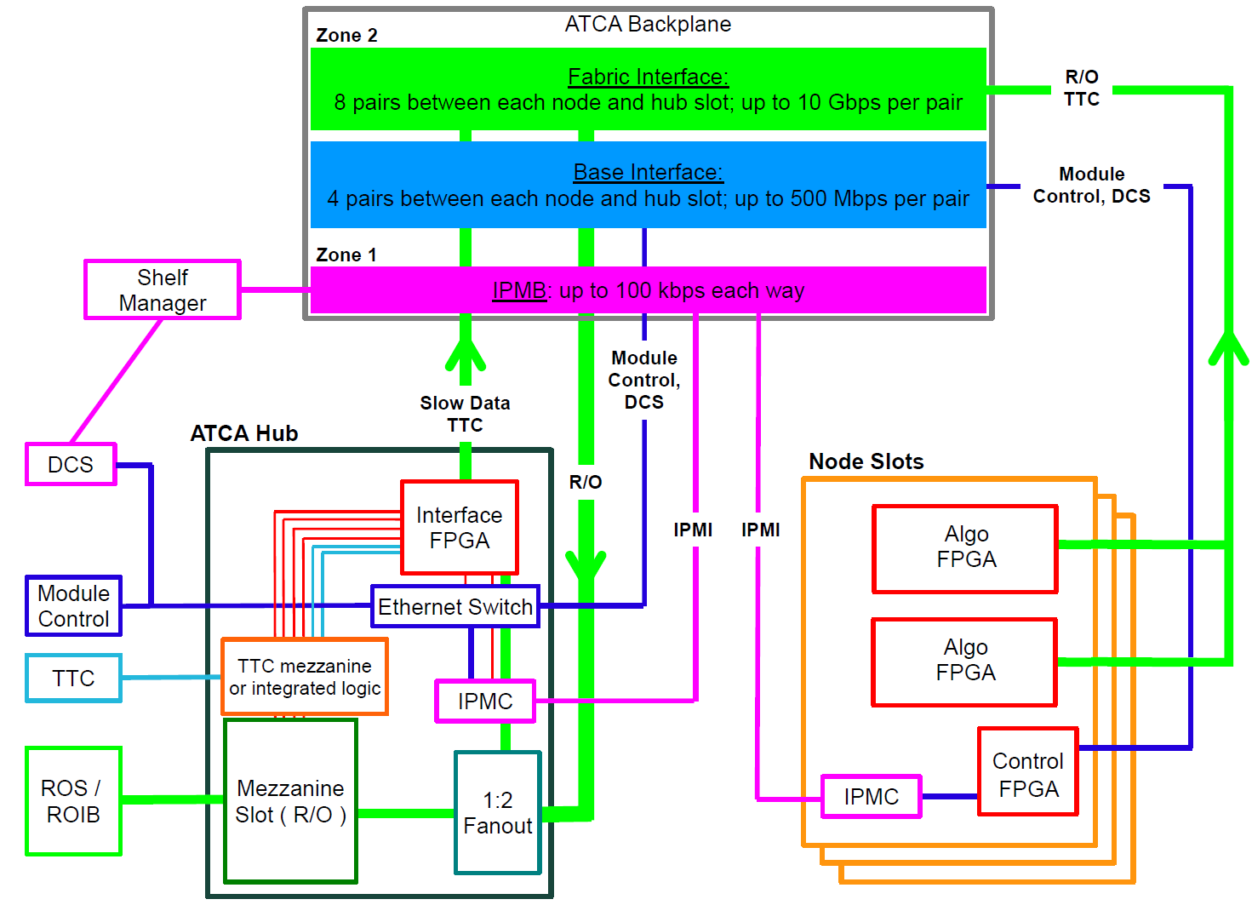

1. The ATCA backplane connections between the L1Topo and the Hub module.

### ATCA Zone 3

ATCA zone 3 houses four 72-way optical MPO connectors. That allows for up to 288 fibres, carrying data from the feature extractors and muons to L1Topo (see section 3.1). These fibres are supported in the L1Topo shelf by a (passive, mechanical) rear transition module (RTM). On the L1Topo side of the connectors, fibre ribbons carry the calorimeter data to MiniPOD receivers, mounted in board. The optical connections are made on the insertion of the L1Topo into the shelf, and broken on its extraction. Dependent on the requirements, real-time output can possibly be run on otherwise dark fibres (spares). However, it is anticipated that real-time optical output connection is rather made via the front panel.

## LEDs

All LEDs defined in the ATCA specifications are located on the L1Topo front panel. In addition, further status LEDs are provided on either the front panel or the top side. These indicate functions like power, Done signals, L1A receipt und further LEDs for diagnostic purposes for all FPGAs.

## Instrument Access Points

### Set-Up and Control Points

The following interfaces are provided for the set-up, control and monitoring of the L1Topo. They are intended for commissioning and diagnostic use only. During normal operation it should not be necessary to access the L1Topo via these interfaces.

* The JTAG Boundary Scan port: via this port a boundary scan test can be conducted, all FPGAs on the L1Topo can be configured, the configuration memory of the Configurator can be loaded and the FPGA diagnostic/evaluation tool ChipScope can be run, including for IBERT tests. This port is on the front panel.
* The 1G Ethernet port (optional): this port provides an auxiliary control interface to the L1Topo, over which IPBus can be run, should there be a problem with, or in the absence of, an IPBus connection over the shelf backplane. It is on the front panel and located on the extension mezzanine.

### Signal Test Points

Due to the sensitive nature of multi-Gb/s signals, no test points are provided on PCB tracks intended to carry multi-Gb/s data. If such signals need to be examined, this must be done via firmware. Test points are placed on a selection of those data and control tracks that are not operating at multi-Gb/s.

For each FPGA, spare, general-purpose IO pins are routed to headers. Furthermore, spare multi-Gb/s transmitters and receivers are routed to SMA sockets. With appropriate firmware these connections allow internal signals, or copies of data received, to be fed to an oscilloscope, for example, or driven from external hardware.

The exact number of test connections, and those signals on which a test point can be placed most usefully, are to be determined in the final stage of module layout.

### Ground Points

At least six ground points are provided, in exposed areas on the top side of the module, to allow oscilloscope probes to be grounded.

## Floor plan

Figure 3 shows a preliminary floor plan of the L1Topo module. This will be used as a guide for the layout process; the exact location of components may change.

The routing of c. 300 signals at multi-Gb/s presents a significant challenge for the design of the L1Topo PCB. In order to minimise track lengths and routing complexity for these signals, the Avago MiniPOD receivers are placed around the Processor FPGAs. However, this creates an additional constraint on the layout: the need to accommodate routing paths for the fibre-optic ribbons carrying the data to these receivers. To connect the MPO connectors to the receivers the ribbons need to twist, curve and bypass large heat sinks on the FPGAs. It can be seen in Figure 3 that large components have been excluded from some areas of the floor plan, to allow space for the routing of the fibre-optic ribbons.

In addition to those components shown in Figure 3, glue logic is placed on the underside of the module.

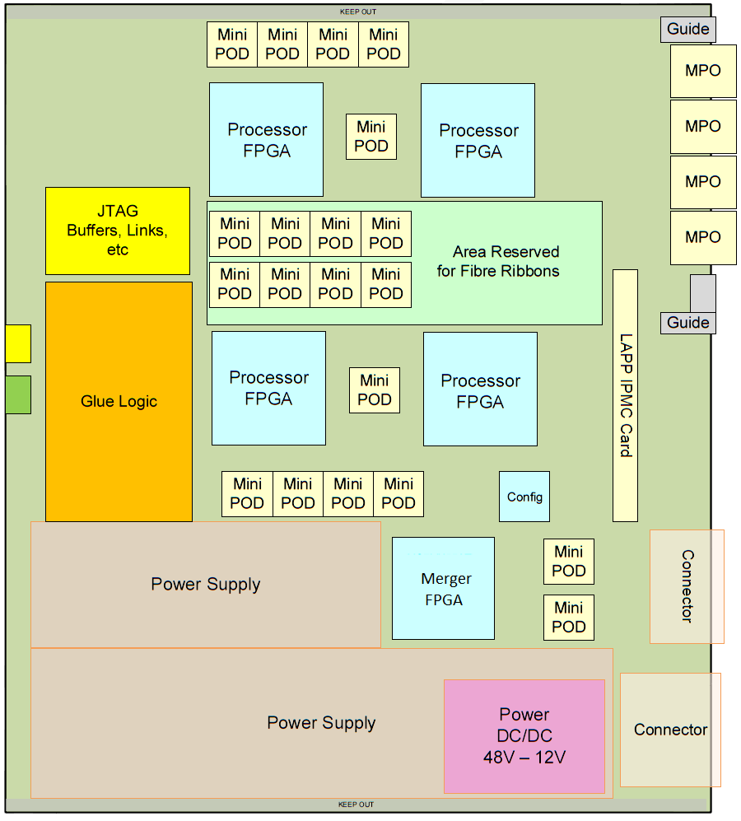

Placeholder, replace with Bruno 3d?

1. A floor plan of the L1Topo, showing a preliminary placement guide.

# Front-Panel Layout—update!

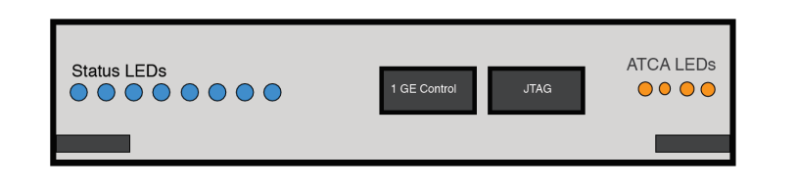

1. Preliminary front panel layout (not to scale).

Figure 4 shows a preliminary template for the front panel layout of the L1Topo. Shown are the JTAG port for boundary scanning and FPGA access, an auxiliary Ethernet control port, status LEDs and the ATCA extraction/insertion handles. These components are not drawn to scale.

# Related Documents

1. ATLAS TDAQ System Phase-I Upgrade Technical Design Report, CERN‑LHCC‑2013‑018, <http://cds.cern.ch/record/1602235/files/ATLAS-TDR-023.pdf>
2. L1Calo Phase-I Hub Specification
3. L1Calo Phase-I ROD specification *(<https://twiki.cern.ch/twiki/pub/Atlas/LevelOneCaloUpgradeModules/Hub-ROD_spec_v0_9.pdf>)*
4. L1Calo Phase-I eFEX Specification *(<https://twiki.cern.ch/twiki/pub/Atlas/LevelOneCaloUpgradeModules/eFEX_spec_v0.2.pdf>)*
5. L1Calo Phase-I jFEX Specification *()*
6. L1Calo Phase-I gFEX Specification *()*
7. L1Calo Phase-I Optical Plant Specification
8. ATCA Short Form Specification, <http://www.picmg.org/pdf/picmg_3_0_shortform.pdf> disappeared, now only <http://www.powerbridge.de/download/know_how/ATCA_Short_spec.pdf>
9. PICMG 3.0 Revision 3.0 AdvancedTCA Base Specification, *access controlled*, <http://www.picmg.com/>
10. L1Calo High-Speed Demonstrator report *(<https://twiki.cern.ch/twiki/pub/Atlas/LevelOneCaloUpgradeModules/HSD_report_v1.02.pdf>)*
11. Foxconn 14Gb/s MiniPOD devices   
    [*http://www.fit-foxconn.com/Product/ProductDetail?topClassID=&&PN=AFBR-824VXYZ*](http://www.fit-foxconn.com/Product/ProductDetail?topClassID=&&PN=AFBR-824VXYZ)
12. Development of an ATCA IPMI controller mezzanine board to be used in the ATCA developments for the ATLAS Liquid Argon upgrade, http://cds.cern.ch/record/1395495/files/ATL-LARG-PROC-2011-008.pdf

# Glossary

|  |  |
| --- | --- |
| ATCA | Advanced Telecommunications Computing Architecture (industry standard). |
| BC | Bunch Crossing: the period of bunch crossings in the LHC and of the clock provided to ATLAS by the TTC, 24.95 ns. |
| DAQ | Data Acquisition. |
| DCS | Detector Control System: the ATLAS system that monitors and controls physical parameters of the sub-systems of the experiment, such as gas pressure, flow-rate, high voltage settings, low-voltage power supplies, temperatures, leakage currents, etc. |
| ECAL | The electromagnetic calorimeters of ATLAS, considered as a single system. |
| eFEX | Electromagnetic Feature Extractor. |
| FEX | Feature Extractor, referring to either an eFEX, gFEX or jFEX module or subsystem. |
| FIFO | A first-in, first-out memory buffer. |
| FPGA | Field-Programmable Gate Array. |
| HCAL | The hadronic calorimeters of ATLAS, considered as a single system. |
| IPBus | An IP-based protocol implementing register-level access over Ethernet for module control and monitoring. |
| IPMB | Intelligent Platform Management Bus: a standard protocol used in ATCA shelves to implement the lowest-level hardware management bus. |
| IPM Controller | Intelligent Platform Management Controller: in ATCA systems, that portion of a module (or other intelligent component of the system) that interfaces to the IPMB. |
| IPMI | Intelligent Platform Management Interface: a specification and mechanism for providing inventory management, monitoring, logging, and control for elements of a computer system. A component of, but not exclusive to, the ATCA standard. |
| jFEX | Jet Feature Extractor. |
| JTAG | A technique, defined by IEEE 1149.1, for transferring data to/from a device using a serial line that connects all relevant registers sequentially. JTAG stands for Joint Technology Assessment Group. |
| L0A | In Run 4, the Level-0 trigger accept signal. |
| L0Calo | In Run 4, the ATLAS Level-0 Calorimeter Trigger. |
| L1A | The Level-1 trigger accept signal. |
| L1Calo | The ATLAS Level-1 Calorimeter Trigger. |
| LHC | Large Hadron Collider. |
| MGT | As defined by Xilinx, this acronym stands for Multi-Gigabit Transceiver. However, it should be noted that it denotes a multi-gigabit transmitter–receiver pair. |
| MiniPOD  MicroPOD | An embedded, 12-channel optical transmitter or receiver.  An embedded, 12-channel optical transmitter or receiver, smaller compared to the MiniPOD. |
| MPO | Multi-fibre Push-On/Pull-Off: a connector for mating two optical fibres. |
| PMA | Physical Media Attachment: a sub-layer of the physical layer of a network protocol. |
| ROD | Readout Driver. |
| RoI | Region of Interest: a geographical region of the experiment, limited in *η* and *φ,* identified by the Level-1 trigger (during Run 3) as containing candidates for Level-2 trigger objects requiring further information. In Run 4, RoIs are used in the same between the Level-0 and Level-1 triggers. |
| Shelf | A crate of ATCA modules. |
| SMA | Sub-Miniature version A: a small, coaxial RF connector. |
| Supercell | LAr calorimeter region formed by combining ET from a number of cells adjacent in *η* and*φ*. |
| TOB | Trigger Object. |
| TTC | The LHC Timing, Trigger and Control system. |
| XTOB | Extended Trigger Object. A data packet passed to the readout path, contained more information than can be accommodated on the real-time path. |

# Document History

|  |  |
| --- | --- |
| **Version** | **Comments** |
| 0.7 | Internal circulation without mezzanine section |
|  |  |
|  |  |
|  |  |
|  |  |
|  |  |

# Summary : Interfaces

Some important details of interfaces to external systems as described above are summarized in this section.

## Internal Interfaces

Do we want that section for eg. Mezzanine connectors ?

## External Interfaces

### Electrical TTC interface (backplane input)

A clean clock of 40.079MHz is received as a differential electrical signal via the ATCA backplane. The signal is AC-coupled on the extension mezzanine and routed into an “any-in” differential receiver or a jitter cleaner????

The clock is accompanied by a TTC data signal, differential, AC coupled on the mezzanine, electrically compatible to Xilinx MGT. The data rate is assumed to be 3.2Gb/s, 8b/10b encoded. Format being defined by the hub designers.

Data paths supported from both hub slots 1 and 2.

### Electrical DAQ interface (backplane output)

Readout data are sent to the DAQ via ATCA backplane on 6 links, LHC bunch clock synchronous(?) AC coupled on L1Topo, Xilinx MGT compatible, below 10Gb/s. Data paths are supported into both hub slots 1 and 2. The data formats are being defined by the hub/ROD community. Readout paths supported from both FPGAs to both hub slots, ie. a total of 4 times 2+1spare link.

### IPbus interface (backplane I/O)

Module control links are standard Gigabit Ethernet via the backplane from/to hub slot 1. The phy chip is located on the extension mezzanine. The envisaged phy chip (VSC8221) allows for magnetics-free, capacitive coupling, which will be the baseline.

### DCS interfaces (backplane I/O)

The IPMC module is linked to the outside world via an I2C (IPMB) bus in ATCA Zone1, and a standard Ethernet link to hub slot 2 via the base interface.

### Electrical CTP interface (front panel output)

The Central Trigger Processor is interfaced electrically via a VHDCI SCSI style connector. Pinout is unchanged with respect to the Phase-0 L1Topo module. Signals level is LVDS. All signal pairs can be driven from the two processor FPGAs. The allocation of pairs to individual FPGAs is implemented on the extension mezzanine. The interface is assumed to be data lines only, though parity and clock signals could be generated in FPGAs if required. The signal level is LVDS.

### Optical CTP interface (front panel output)

The Central Trigger Processor is interfaced fibre-optically via an MTP/MPO connector on the front panel. Up to 48 total fibres can be driven from the two processor FPGAs through MiniPODs. The maximum bitrate is 14Gb/s, the interface is assumed to run at 6.4/12.8 Gb/s synchronous to the LHC clock. Data encoding is 8b/10b.

### Optical FEX/Muon interface (rear input)

The calorimeter FEXes (e/j/g-FEX) and the muon trigger are fibre-optically interfaced via the backplane, on 72-way MTP/MPO connectors. The mechanical interface to the RTM is Molex MTP-CPI. Four of these shrouds are available in ATCA Zone3. The signals are routed through MiniPODs (up to 14 Gb/s) and received into FPGAs via GTH/GTY links. Encoding is 8b/10b. Data rate is specified for mixed operation 11.2/12.8Gb/s. Signal rates are not to be mixed in same quad.

# Appendix : Data formats

The formats of the data received and generated by L1Topo are about to be finalised. Details are found in separate documents. This section gives a coarse overview only.

## Real-Time Input Data

Real-time input from FEXes and Muon Trigger is 8b/10b-encoded at 11.2 or 12.8 Gb/s. This yields a line capacity of 224 or 256 bits total per bunch crossing. The raw data are accompanied by a CRC check sum and by comma characters, required for line synchronization. Comma characters are sent upon link start-up and in otherwise empty data fields, replacing 0x00 data bytes. Comma characters are injected in fixed and unique positions within a full-BC data word only. For purpose of overall alignment and monitoring bunch count information is embedded into the data stream as well.

## Real-Time Output Data

The Real-time output of L1Topo into the CTP is composed of trigger information, accompanied by overflow information, one overflow bit per trigger bit (?). On the electrical interface this information is sent without any further formatting, as an 80Mb/s stream. On the optical interface the raw data will be protected by a CRC check sum and aligned with help of embedded comma characters, plus overall alignment with embedded bunch count information.

## Backplane data formats

Readout streams into DAQ and RoI systems are routed through the two hub/ROD modules in the shelf. The formats on the data links are defined by the ROD community. It should be noted that it will not be possible to run all DAQ or RoI output in a channel bonded scheme, since it is actually two separate streams from distinct sources, the two processor FPGAs.

The TTC data running on the backplane from the hub modules to the L1Topo modules are re-coded on the hub. The exact protocol is being defined by the hub designer community.